BHADERWAH CAMPUS UNIVERSITY OF JAMMU

BACHELORS IN COMPUTER APPLICATIONS
(BCA-3rd SEMESTER 2024-28)
PRACTICAL FILE
DIGITAL ELECTRONICS

SUBMITTED BY: SUBMITTED TO:
Abdul Majeed Ms. Diksha Sambyal
313040001 (Course Incharge)
Dept. Of CS and IT

ACKNOWLEDGEMENT
I would like to express my gratitude to all those people who helped me to complete this practical file. I want to thank all the faculty members of Computer Science and IT Department for providing me all the tools and resources for the completion of my practical file.
I have further more to thank our respected teacher Ms. Diksha Sambyal who encouraged me to move ahead and complete my work in time.
At last, I want to thank my classmates and friends for their help, support, interest and valuable hints. I want to thank once again all the above mentioned persons for their time and help.
Thank you.
Abdul Majeed
BCA 3rd semester
313040001

CERTIFICATE
This is to certify that Abdul Majeed student of BCA 3rd semester bearing university Roll no. 313040001 has completed that required number of practicals of Digital Electronics under the guidance of class teacher Ms. Diksha Sambyal from the Department of Computer science and IT, Bhaderwah campus, University of Jammu.

Signature. Signature.
(Practical I/C) (Course Coordinate)

1:- Verification of Basic Logic Gates – AND, OR, NOT

- AND Gate:-

Circuit of AND Gate:
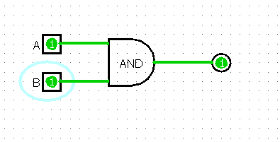
Truth table of AND Gate:
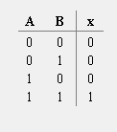
Expression of AND Gate:

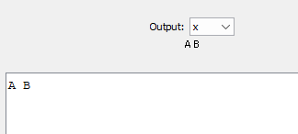

- OR Gate:-

Circuit of OR Gate:
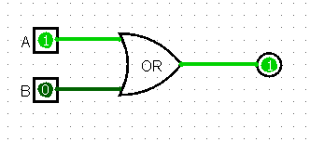
Truth table of OR Gate:
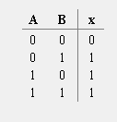

Expression of OR Gate:
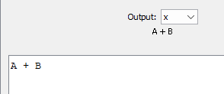

- NOT Gate:-

Circuit of NOT Gate:
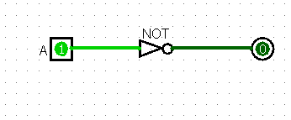
Truth table of NOT Gate:
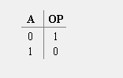

Expression of NOT Gate:
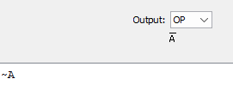

2:- Verification of Derived Logic Gates – NAND, NOR, XOR, XNOR

- NAND Gate:-

Circuit of NAND Gate:
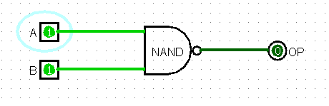
Truth table of NAND Gate:
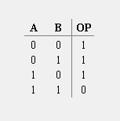

Expression of NAND Gate:
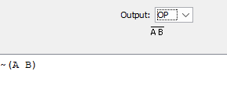

- NOR Gate:-

Circuit of NOR Gate:
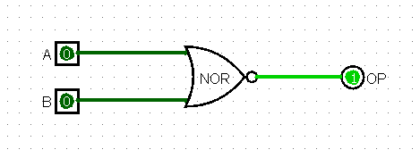
Truth table of NOR Gate:
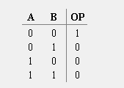

Expression of NOR Gate:
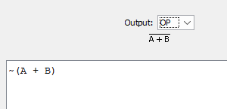

- XOR Gate:-

Circuit of XOR Gate:
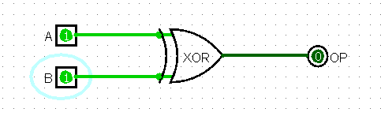
Truth table of XOR Gate:
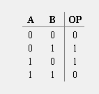

Expression of XOR Gate:
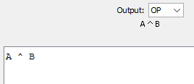

- XNOR Gate:-

Circuit of XNOR Gate:
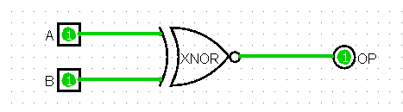
Truth table of XNOR Gate:
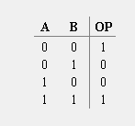

Expression of XNOR Gate:
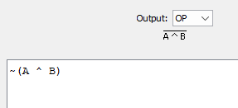

3:- Implementation of XOR and XNOR Using Basic Gates
- XOR Using Basic Gates:-
Circuit of XOR Gate using basic Gates:
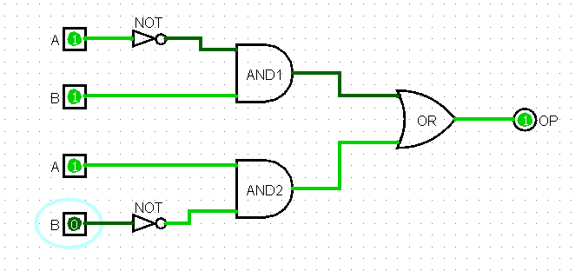
Truth table of XOR Gate using basic Gates:
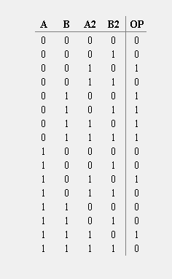
Expression of XOR Gate using basic Gates:
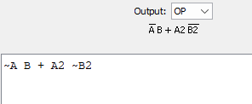

- XNOR Using Basic Gates:-
Circuit of XNOR Gate using basic Gates:
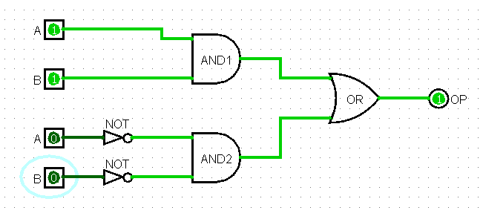
Truth table of XNOR Gate using basic Gates:
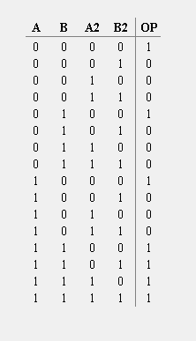
Expression of XNOR Gate using basic Gates:
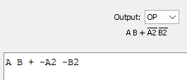

4:- Universal Gates Implementation Using NAND – Realization of AND, OR, NOT

- NOT Using NAND:-

Circuit of NOT Gate using NAND Gates:
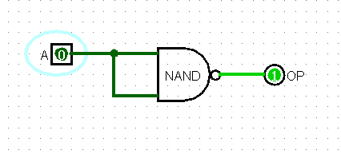
Truth table of NOT Gate using NAND Gates:
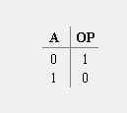
Expression of NOT Gate using NAND Gates:
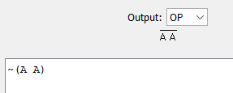

- AND Using NAND:-

Circuit of AND Gate using NAND Gates:
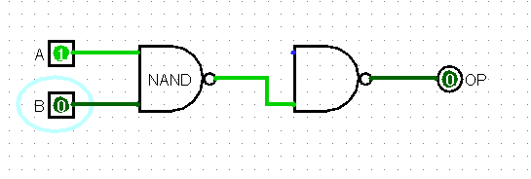
Truth table of AND Gate using NAND Gates:
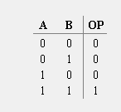
Expression of AND Gate using NAND Gates:

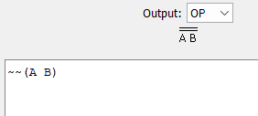

- OR Using NAND:-

Circuit of OR Gate using NAND Gates:
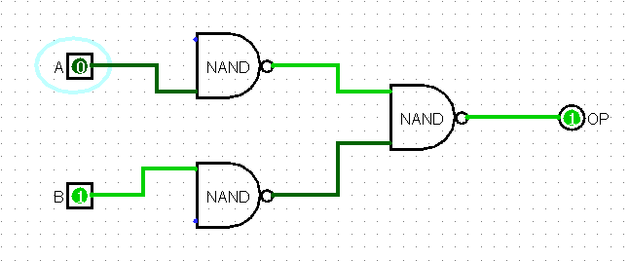
Truth table of OR Gate using NAND Gates:
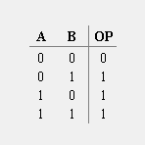
Expression of OR Gate using NAND Gates:

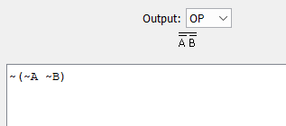

5:- Universal Gates Implementation Using NOR – Realization of AND, OR, NOT

- NOT Using NOR:-

Circuit of NOT Gate using NOR Gates:
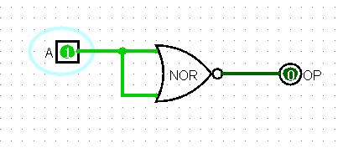
Truth table of NOT Gate using NOR Gates:
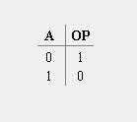
Expression of NOT Gate using NOR Gates:
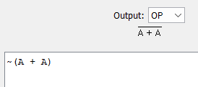

- AND Using NOR:-

Circuit of AND Gate using NOR Gates:
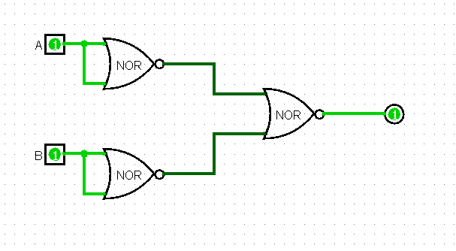
Truth table of AND Gate using NOR Gates:
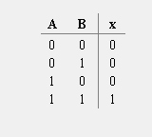
Expression of AND Gate using NOR Gates:

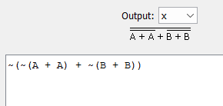

- OR Using NOR:-

Circuit of OR Gate using NOR Gates:
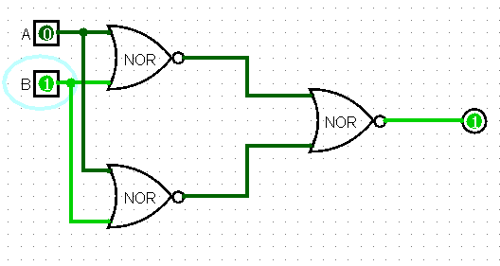
Truth table of OR Gate using NOR Gates:
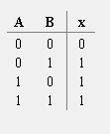
Expression of OR Gate using NOR Gates:
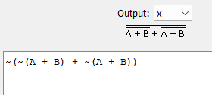

6:- Design and Verification of Adders – Half Adder & Full Adder

- HALF ADDER:-

Circuit diagram of HALF ADDER:
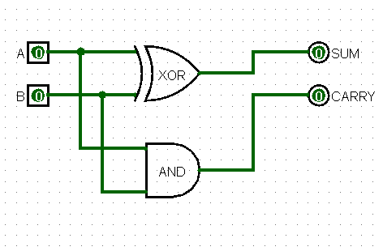
Truth table of HALF ADDER:
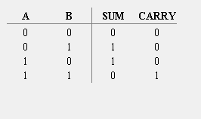
Expression of HALF ADDER:
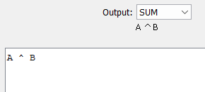

- FULL ADDER:-
Circuit diagram of FULL ADDER:
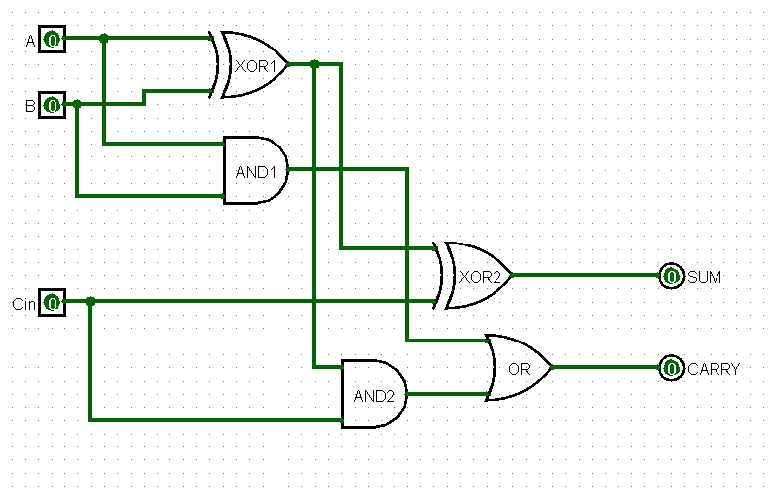
Truth table of FULL ADDER:
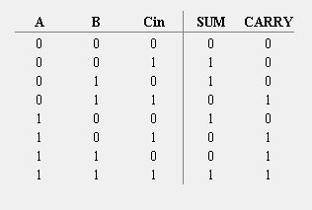
Expression of FULL ADDER:
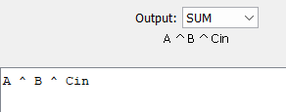

7:- Design and Verification of Subtractors – Half Subtractor & Full Subtractor

- HALF SUBTRACTOR:-

Circuit diagram of HALF SUBTRACTOR:
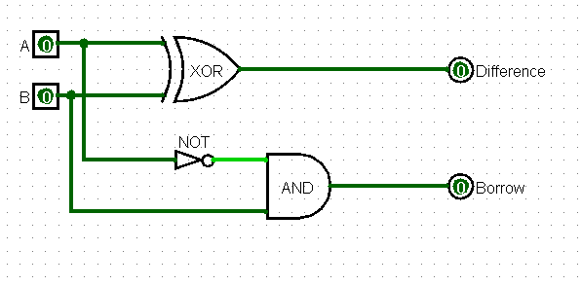
Truth table of HALF SUBTRACTOR:
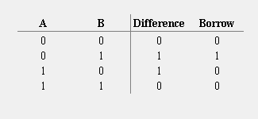
Expression of HALF SUBTRACTOR:
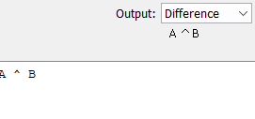

- FULL SUBTRACTOR:-
Circuit diagram of FULL SUBTRACTOR:
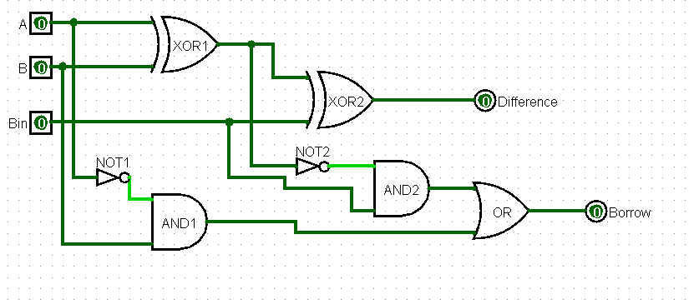
Truth table of FULL SUBTRACTOR:
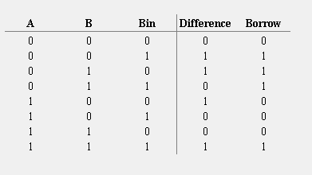
Expression of FULL SUBTRACTOR:
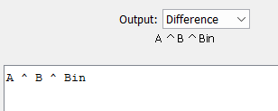

8:- Design and Implementation of Multiplexers – 4:1 MUX

Circuit diagram of MULTIPLEXER --- 4:1 MUX:
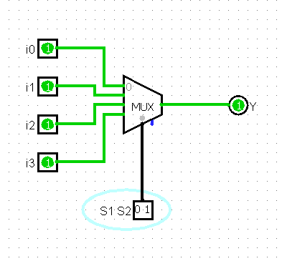
Truth table of MULTIPLEXER --- 4:1 MUX:
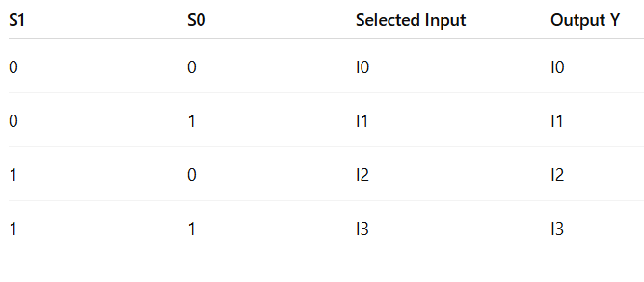

9:- Design and Implementation of Demultiplexers – 1:4 DEMUX

Circuit diagram of DEMULTIPLEXER --- 1:4 DEMUX:
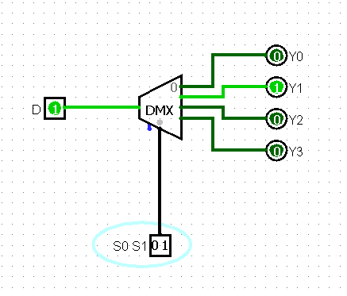
Truth table of DEMULTIPLEXER --- 1:4 DEMUX:

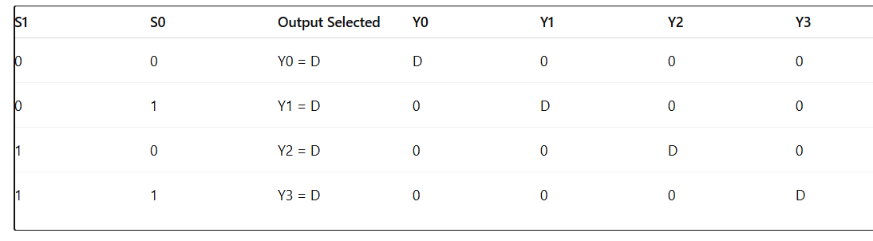

10:- Design and Verification of Flip-Flops – SR Flip-Flop & JK Flip-Flop

- SR FLIP-FLOP:-

Circuit diagram of SR FLIP-FLOP:
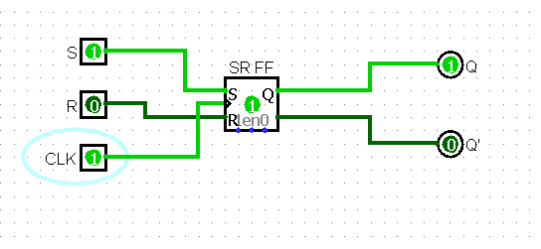
Truth table of SR FLIP-FLOP:

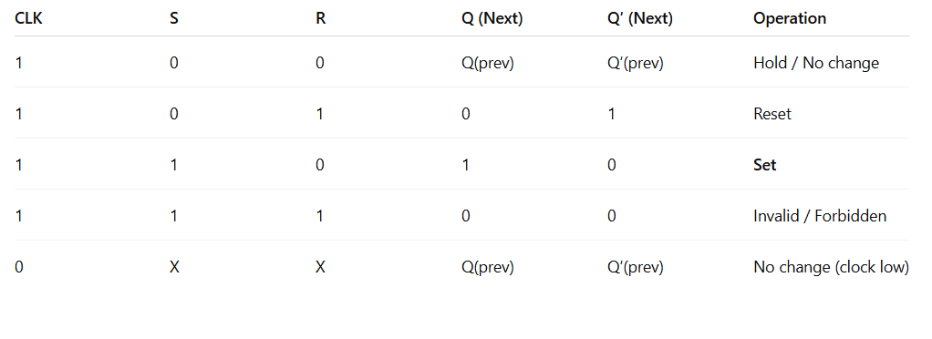

- JK FLIP-FLOP:-

Circuit diagram of JK FLIP-FLOP:
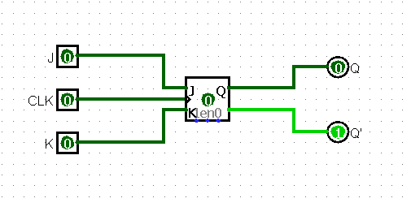
Truth table of JK FLIP-FLOP:

